# CS 255 Business Requirements Document Template

Complete this template by replacing the bracketed text with the relevant information.

This template lays out all the different sections that you need to complete for Project One. Each section has guiding questions to prompt your thinking. These questions are meant to guide your initial responses to each area. You are encouraged to go beyond these questions using what you have learned in your readings. You will need to continually reference the interview transcript as you work to make sure that you are addressing your client’s needs. There is no required length for the final document. Instead, the goal is to complete each section based on your client’s needs.

**Tip:** You should respond in a bulleted list for each section. This will make your thoughts easier to reference when you move into the design phase for Project Two. One starter bullet has been provided for you in each section, but you will need to add more.

## System Components and Design

### Purpose

*What is the purpose of this project? Who is the client and what do they want their system to be able to do?*

As the consulting agency, we are committed to designing an application that meets or exceeds the needs of the client, DriverPass. To build an effective high-quality product, it is essential to consider the goals of the client during each step of the design process. The client, DriverPass, owned by Liam, is striving to fill a community need by developing a program that helps prepare customers to take the driver’s test at the local MVD. DriverPass envisions a comprehensive system that combines online learning material, practice exams, classroom instruction, and on the road training. The system would include managing the appoints of students, cars, and instructors for on the road training.

### System Background

*What does DriverPass want the system to do? What is the problem they want to fix? What are the different components needed for this system?*

* DriverPass has noted far too many potential drivers struggle to pass the driving test.
* As a company DriverPass wishes to aid those who are planning to take the driving test by providing in-person instruction, online curriculum, online practice exams and driving lessons.
* DriverPass envisions a well-rounded and robust system that the consumer can tailor to meet individual needs.
* They also want their program to stay current with any changes made by the DMV.
* Their system will require:
  + A modifiable schedule for drivers, cars, and students.
  + Online curriculum and practice exams.
  + A database of users with saved attributes.
  + Automate password reset.
  + Different user groups with distinct permissions and interfaces.
  + Cloud based operations.
  + Exportable reports.
  + Activity tracking.

### Objectives and Goals

*What should this system be able to do when it is completed? What measurable tasks need to be included in the system design to achieve this?*

These are the capabilities that should be included in the solution.

* + Accessible from any connected device.
  + Exportable reports
  + Customers can choose a package that meets their needs.
  + Packages must be customizable.
  + Packages must be able to be disabled.
  + Secretary able to create new users when customers call in.
  + Staff able to modify schedule.
  + Users need to be able to access online learning material.
  + Users need to be able to take practice exams.
  + Users should be able to schedule driving lessons in 2-hour blocks.
  + Users should be able to modify their schedule.
  + IT able to block users.
  + Able to track changes in the system to reservations.
  + Needs different roles for users with differing permissions.
  + Driving instructors should be able to make notes/comments for each lesson.
  + System needs to track driver and car for each lesson.
  + System needs to securely store attributes for each user.
  + System should be cloud based.
  + The owner, Liam, should be able to run/control system.
  + Automated password reset.

## Requirements

### Nonfunctional Requirements

*In this section, you will detail the different nonfunctional requirements for the DriverPass system. You will need to think about the different things that the system needs to function properly.*

#### Performance Requirements

*What environments (web-based, application, etc.) does this system need to run in? How fast should the system run? How often should the system be updated?*

* DriverPass requires a web-based application and users will need to access the system from mobile phones, tablets, Windows PCs, and Macs. There is a wide variety of devices that users utilize to operate the system. Student drivers will use this system at times that are convenient for the student, as such the system will need to be accessible around the clock. Updates should be done monthly to maintain accurate reflection of changes made at the DMV as well as staying current on security and antivirus patches. The system should adhere to modern standards of “less than two-second average server response time and a page response threshold of two seconds…to keep users happy and engaged.” (Lambda Solutions, 2014).

#### Platform Constraints

*What platforms (Windows, Unix, etc.) should the system run on? Does the back end require any tools, such as a database, to support this application?*

* For accessibility DriverPass’ system should run on both Windows and Unix devices as well as the mobile platforms, Apple, and Android. The system will require a back-end database to securely store user information and the learning material. In addition, the system needs to connect with the DMV to receive updates so they can ensure their material is kept current.

#### Accuracy and Precision

*How will you distinguish between different users?* *Is the input case-sensitive? When should the system inform the admin of a problem?*

* The system will need each user to be unique, it will use users’ email as the usernames’ and will require a password to secure each account. Passwords will be case-sensitive although the usernames should not be case-sensitive. Other input fields such as address and telephone should accept only the desire response type (ie string and integer) but do not need to be case-specific. The administrator should be informed if the user responds to the notification that the suspicious login attempts were not made by the user. The administrator should also be notified immediately of any changes made to the system or any disruptions in service.

#### Adaptability

*Can you make changes to the user (add/remove/modify) without changing code? How will the system adapt to platform updates? What type of access does the IT admin need?*

* The system will utilize a user class so that changes can be made to users without modifying code. The system should “be able to react and adapt to changes in the environment that might occur and affect its operations. Moreover, due to the dynamicity of the environment, the adaptation must be postponed as much as possible to the runtime execution of applications, when the environment is known... without an adhoc reconfiguration from the developers.” (De Sanctis et al., 2020) This means DriverPass’ system will adapt to platform updates with minimal code changes.
* The IT administrator will need elevated administrative privileges that will allow for tracking changes, modifying user accounts, and deploying released updates.

#### Security

*What is required for the user to log in? How can you secure the connection or the data exchange between the client and the server? What should happen to the account if there is a “brute force” hacking attempt? What happens if the user forgets their password?*

* Passwords will be case-sensitive although the usernames should not be case-sensitive. Student driver accounts will store payment information so two-factor authentication should be utilized with one-time use codes sent to the email or phone number in their account. 3 unsuccessful password attempts should lock account for 10 minutes and send the user a notification. The administrator should be informed if the user responds to the notification that the suspicious login attempts were not made by the user.
* If there is a “brute force” hacking attempt the account should be locked until the user verifies their information and changes their password. Brute force hacking should be thwarted by the second layer of the two-factor authentication but changing the password is recommended.
* The user should be able to reset their password using an automated service that requires two-factor authentication. This can be answering security questions and then a one-time use code sent to the email or phone number on file. The second option is to authenticate via a code sent to the email on file as well as one sent by text to the phone number on file.
* The connection between client and servers should be secured using TLS 1.3 as payment information is included for the user accounts.

### Functional Requirements

*Using the information from the scenario, think about the different functions the system needs to provide. Each of your bullets should start with “The system shall . . .” For example, one functional requirement might be, “The system shall validate user credentials when logging in.”*

* The system shall validate user credentials when logging in, using two-factor authentication.
  + The system shall securely store attributes for each user.
  + The system shall allow for different roles for users with differing permissions.
* The system shall check the user’s permission level prior to completing a secure task.
  + The system shall allow customers to choose between customizable packages.
  + The system shall allow the owner to disable packages.
  + The system shall allow the secretary to create new users.
  + The system shall allow staff to modify the schedule.
  + The system shall provide access to online learning material.
  + The system shall contain practice exams that users can take.
  + The system shall allow users to schedule driving lessons in 2-hour blocks.
  + The system shall allow users to modify their schedule.
  + The system shall allow IT to modify users.
  + The system shall allow IT to block users.
  + The system shall track changes in the system.
  + The system shall provide exportable reports.
  + The system shall allow driving instructors to make notes/comments for each lesson.
  + The system shall track the driver and car for each lesson.
  + The system shall be cloud based.
  + The system shall allow the owner to control the system.
  + The system shall provide a secure automated password reset.
  + The system shall notify the user of 3 sequential unsuccessful password attempts.
  + The system shall lock accounts after unsuccessful password attempts.
  + The system shall send a notification to IT of any changes to the system or disruption in services.

### User Interface

*What are the needs of the interface? Who are the different users for this interface? What will each user need to be able to do through the interface? How will the user interact with the interface (mobile, browser, etc.)?*

* The interface will be a graphic user interface. It will present a different interface for drivers, IT, the secretary, the owner, and student drivers.
* The users will interact with the interface via an application if accessing via a mobile device or an internet browser if accessing via a PC.
* The drivers’ interface will allow for modification of their schedule. It will contain information on each student they are schedule with as well as the car they are scheduled to use. The drivers’ interface will provide a section for adding comments for the student after each lesson.
* The students’ interface will contain the following sections:
  + Online learning material
  + Online practice tests
  + Progress tracking
  + Driver’s notes
  + Special needs
  + Driver photo
  + Student photo
  + Package information
  + Schedule
* The secretary’s interface will have a section for adding student driver accounts. It will show the schedules for all drivers and students and allow the secretary to modify the schedules as needed.
* The IT interface contain the following sections:
  + Pending updates
  + Completed updates
  + Security notifications
  + System status
  + Tracking reports
  + Manage User Accounts
* The owner interface will contain the following sections:
  + Active Packages
  + Exportable Reports
  + Sales Tracking

### Assumptions

*What things were not specifically addressed in your design above? What assumptions are you making in your design about the users or the technology they have?*

* Users possess internet capable devices.
* System has internet connectivity around the clock.
* System has consistent power source.
* Users’ devices have power source.

### Limitations

*Any system you build will naturally have limitations. What limitations do you see in your system design? What limitations do you have as far as resources, time, budget, or technology?*

* Internet bandwidth on both the server and client sides.
* DriverPass has minimal resources to monitor backups and security after system is deployed.
* The project needs to stay within the budget for initial development to balance cost with projected revenue.
* The project must adhere to schedule provided in contractual agreement avoid impacting projected revenue.

### Gantt Chart

*Please include a screenshot of the GANTT chart that you created with Lucidchart. Be sure to check that it meets the plan described by the characters in the interview.*

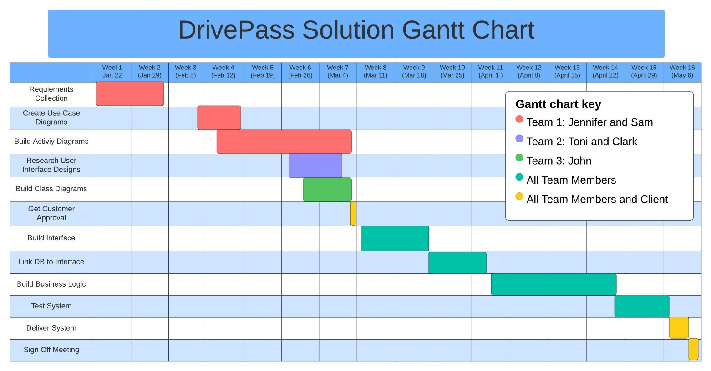

Resources

De Sanctis, M., Bucchiarone, A., & Marconi, A. (2020). Dynamic adaptation of service-based applications: A design for adaptation approach. *Journal of Internet Services and Applications*, *11*(1). https://doi.org/10.1186/s13174-020-00123-6

Lambda Solutions. (2014, May 1). *LMS reliability: Uptime and learner engagement*. https://www.lambdasolutions.net/blog/reliable-lms-uptime-learner-engagement